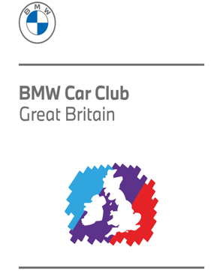
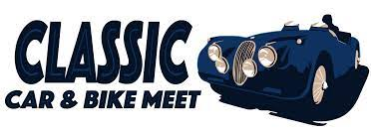

BMW M’FEST 2022
Wednesday 6th July, Earls Barton Showground, NN6 0HF
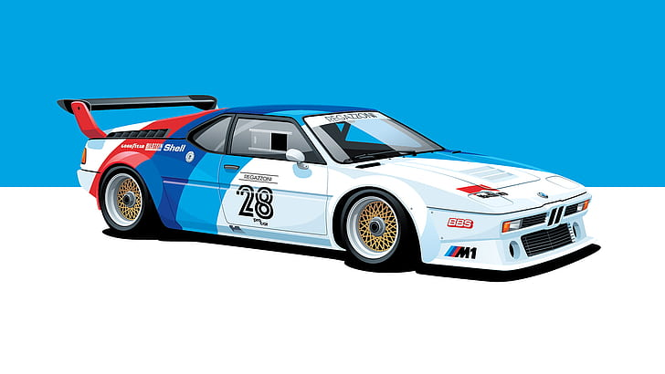CELEBRATING 70 YEARS OF BMW CAR CLUB and 50 years of ‘M’

For more information visit www.ClassicCarMeet.co.uk

